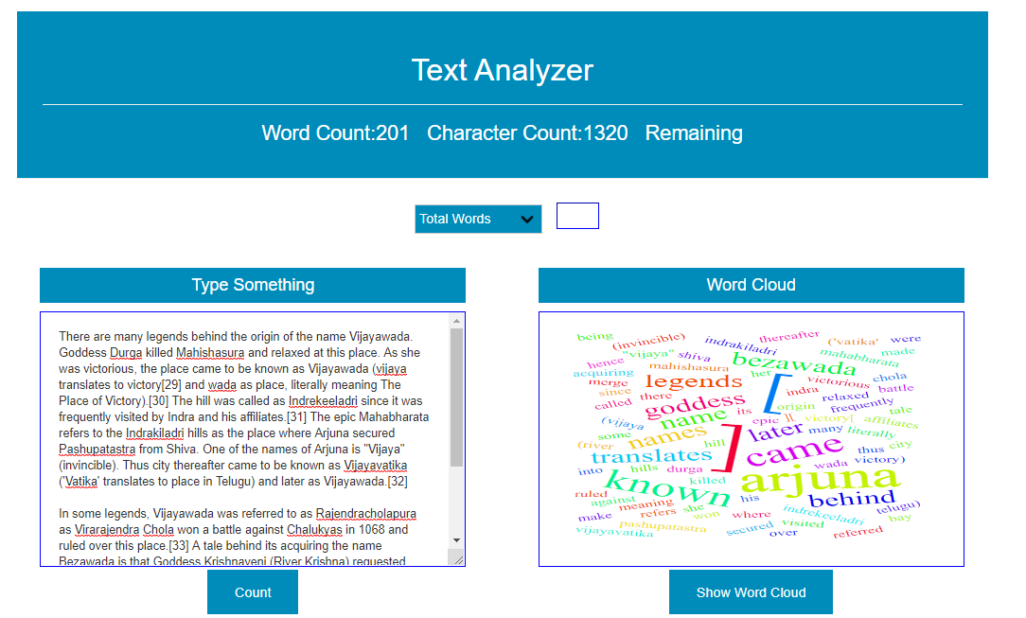

Can toggle between words and characters.

Indicates in red color if word limit has crossed.

